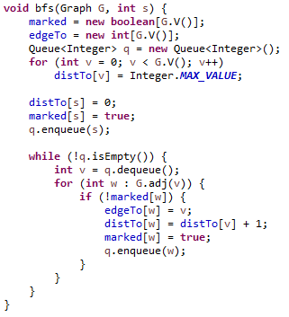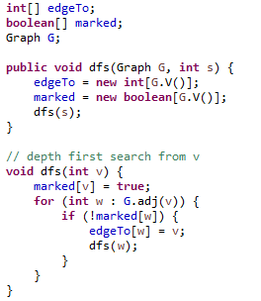

* Show the state of the Stack (DFS) and Queue (BFS) for search (0) once you mark V7 with **marked[w] = true**
* **for (int w : G.adj(v))** returns by ascending ID
* In DFS, mark node with “X”. In BFS, mark node with **DistTo** value
* Show **edgeTo** values by drawing “back arrows” over the edges. For example, in both cases, there should be back edge from V3 to V0.

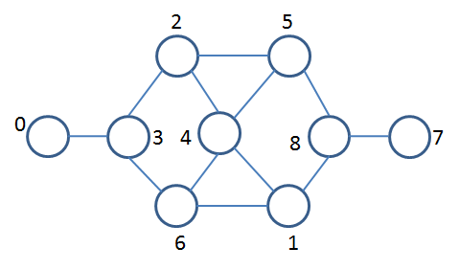



**Call Stack: Queue:**